

**MS4**

Andrew Nady 900184042

Salma Soliman 900182325

### **Table of content**

Introduction …………………………………………………………………………………. 3

Single cycle processor …………………………………………………………………………. 4

Decreasing the clock …………………………………………………………………………. 5

Pipelined implementation ……………………………………………………………….………6

Hazard ………………………………………………………………………………….………. 7

Design ………………………………………………………………………………….………. 10

Testing ………………………………………………………………………………….………. 12

Bonus ………………………………………………………………………………….………. 23

### **RISC V Pipelined Cycle Microprocessor**

**Introduction:**

**We are designing a RISC-V processor that supports the base integer instruction set according to the specifications found here:** [**https://riscv.org/technical/specifications/**](https://riscv.org/technical/specifications/) **We implemented each instruction according to the specification found on, page 130 of the RISC-V Instruction Set Manual –Volume I: Unprivileged ISA and explained in Chapter2 of the same manual.**

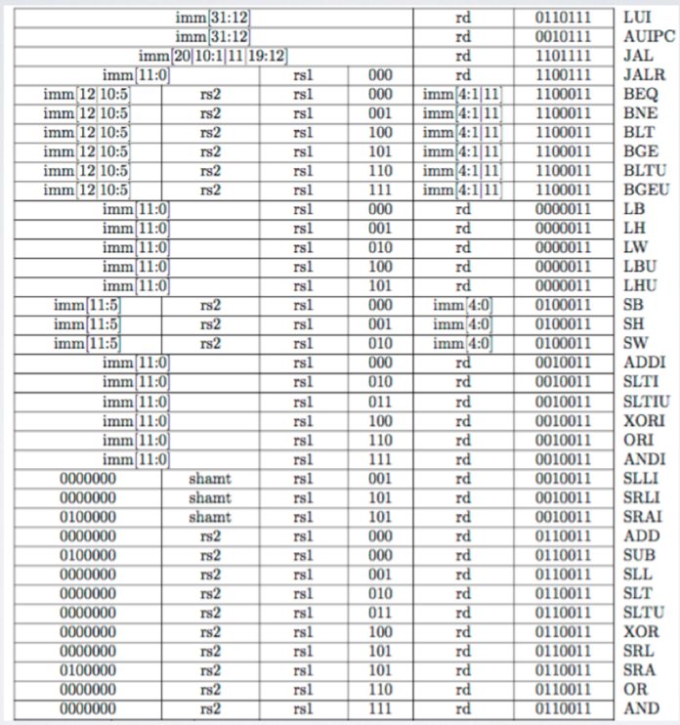

**Single Cycle implementation:**

We begin implementing the single-cycle processor. A single cycle processor is a processor that carries out one instruction in a singleclock cycle. The benefits of single-cycle processors are that they tend to be the most simple in terms of hardware requirements, and they are easy to design. Unfortunately, they tend to have poor data throughput and require long clock cycles (slow clock rate) in order to perform all the necessary computations in time. The length of the cycle must be long enough to accommodate the longest possible propagation delay in the processor. This means that some instructions will complete quickly, and time will be wasted each cycle. Other instructions (typically memory read or write instructions) will have a much longer propagation delay. (need to add link of one of our githubs)

**Our design**

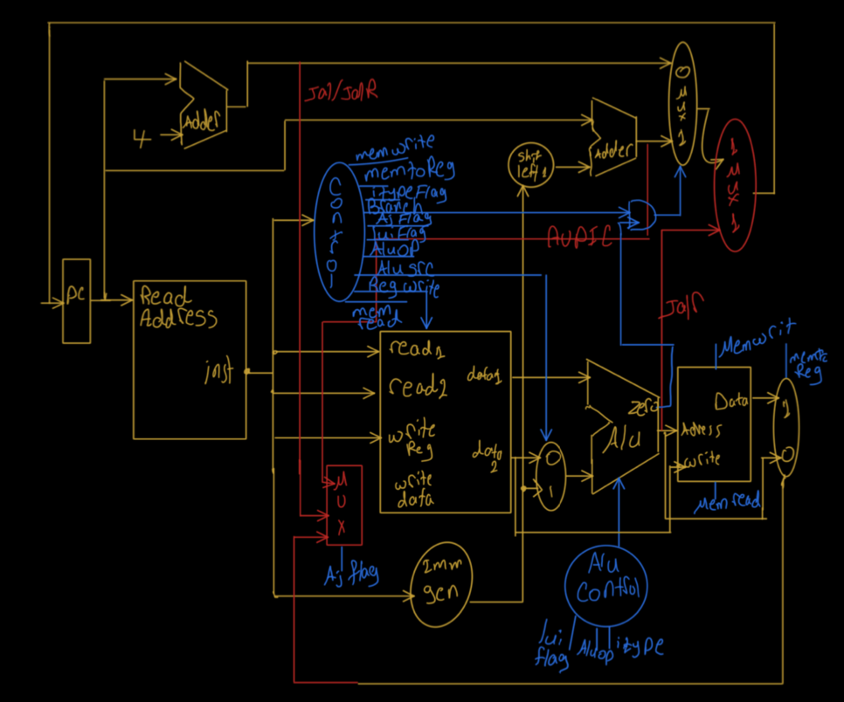

**Decreasing the clock cycle:**

When comparing all the instruction to each other will find the Load word will take the longest time possible, which will be the same as the instruction execution time in the single-cycle processor

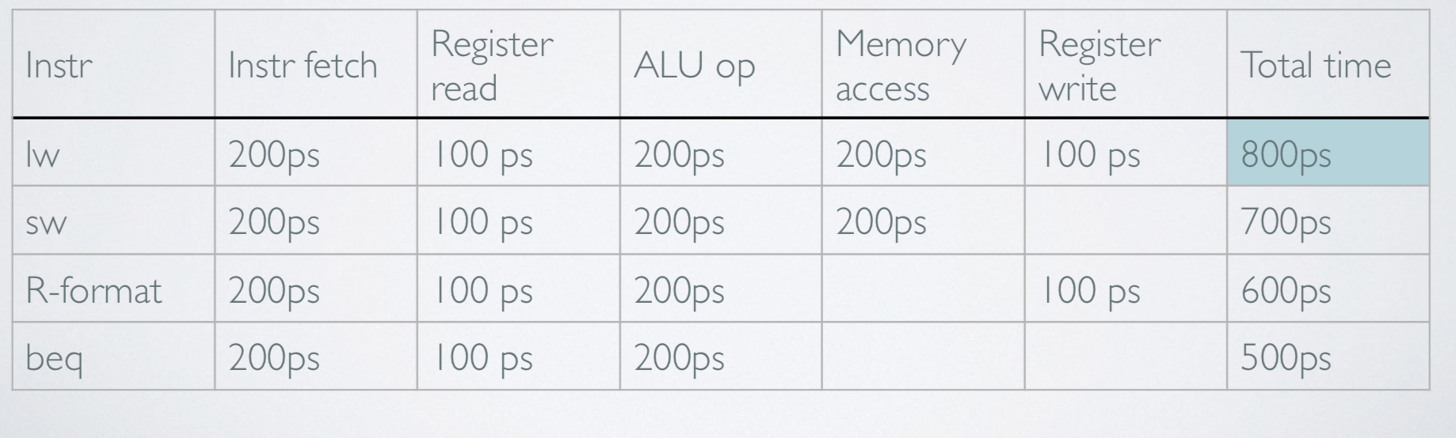

As we can see that every instruction fetching is done after 200 ps and stay deactivated till all the following operations finish. So we need to make every single operation not to wait. So we begin designing the Pipeline processor. In the half of the following picture, you can that for example the instruction fetching does not wait until other operations finish. So if we ignore the warming up of the pipelined, each instruction will take 200 ps. So, the speedup is improved by 5 times. Let’s discuss it in more details

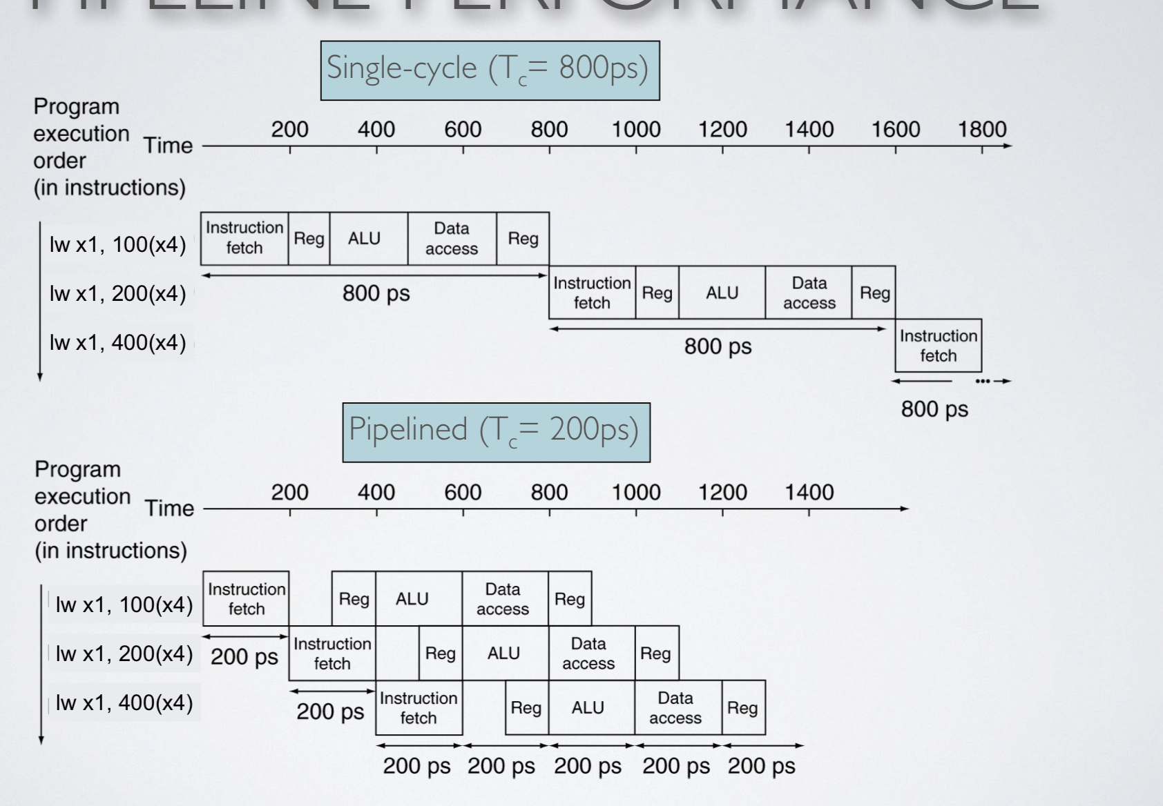

**Pipelined implementation:**

instruction pipelining is a technique for implementing instruction-level-parallelism within a single processor. Pipelining attempts to keep every part of the processor busy with some instruction by dividing incoming instructions into a series of sequential steps with different parts of instructions processed in parallel.

So how can we improve our single-cycle processor to make it pipelined, all we have to make is a buffer system to save the values of the previous phases to be used in the next phase and let the current phase begin work on a new instruction. That is why we added extra components to the single cycle which are mainly 5 additional registers to pipeline the instructions over five stages from memory

2.ID: Instruction decode & register read

3.EX: Execute operation or calculate the address

4.MEM: Access memory operand

5.WB: Write result back to register

However, it is so fast compared to the single-cycle processor, with the below design we faced many problems which hazards which will need more improvement to our processor

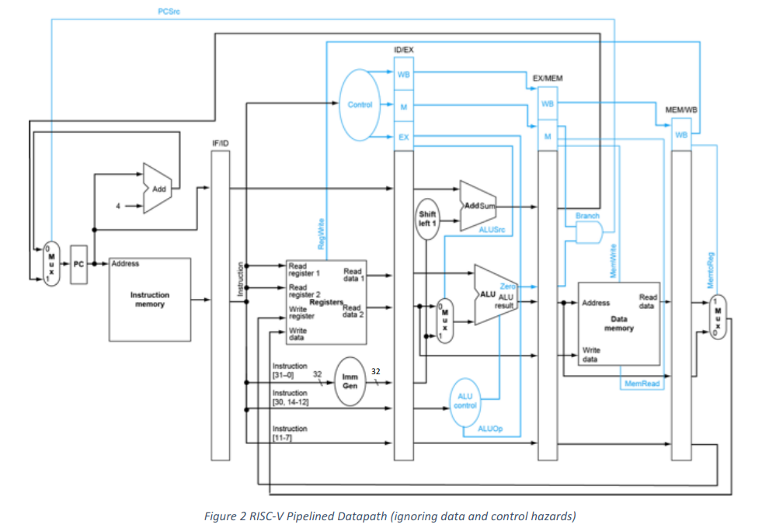

**Hazards:**

We have 2 main hazards in the above design which are data and control hazard:

* Data hazards: needs to wait for the previous instruction to complete its data read/write
* control hazard: deciding on control action depending on the previous instruction

1. **Data hazards:**

An instruction depends on the completion of data access by a previous instruction.

Think of the following example: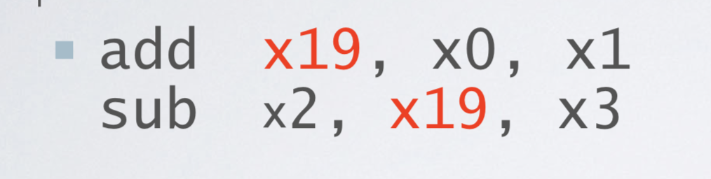

First, we need to write in the x19 register, and then it is used in the next instruction. This will make a problem as the x19 will be modified in cycle 5th and the decoding of the next instruction will be in the 3rd cycle.

* So this will make the next instruction bubble and waits till the writing back stage finished which will cost a 2 cycle.

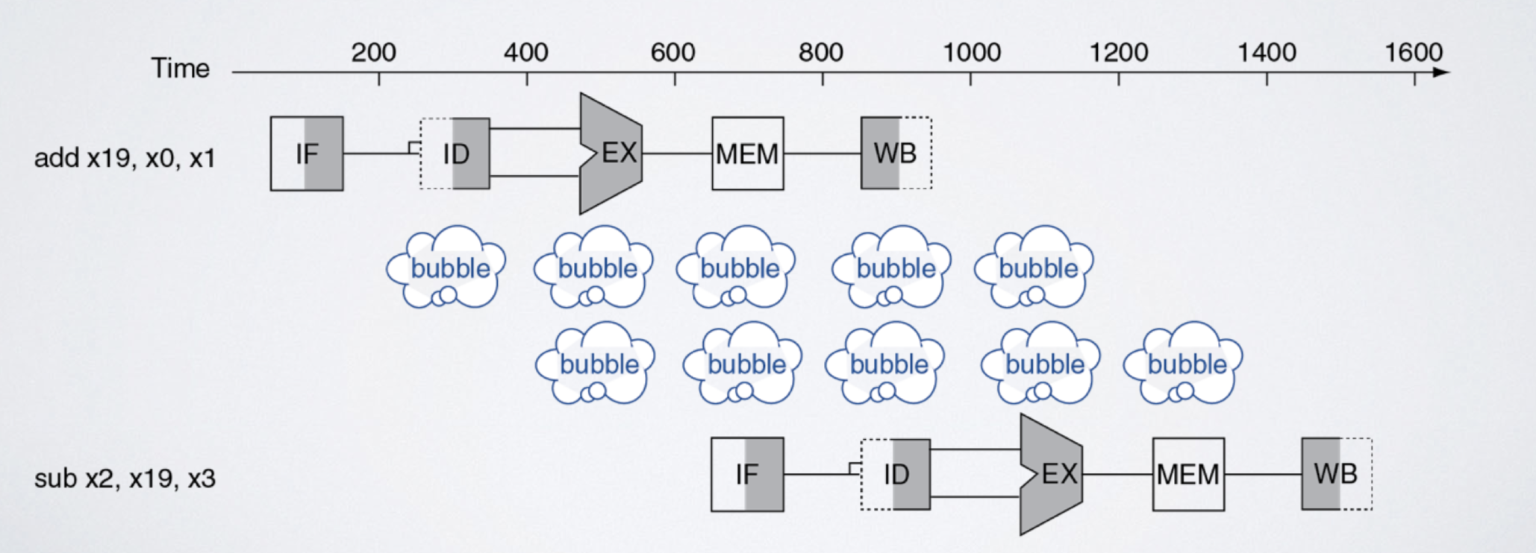

* So we need to think about an efficient solution to minimize the bubbles
* As the execution of the first instruction is finished in the 3rd cycle and the execution of the next instruction in the 4th cycle, then we can forward the data of the x19 to the next instruction even modifying it.

**Forwarding:**

To solve the problem of data hazards, a forwarding technique should be implemented to forward the data that are in the EX stage or MEM stage. We implemented that by adding a forwarding unit that controls 2 multiplixers that control both inputs of the ALU.

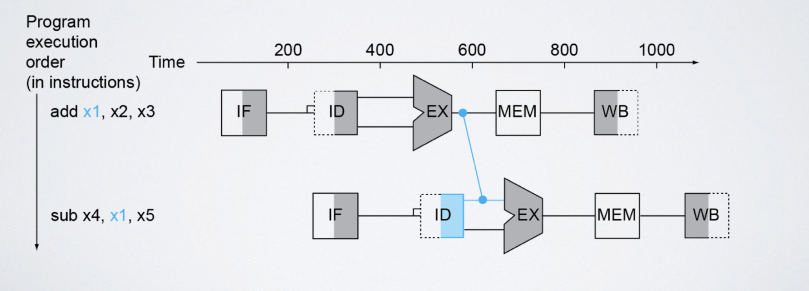

**load hazards :**

Those hazards arise from the memory write/read instructions (LW, SW,..). Those are kind of instructions that need additional clock cycle (stall) to write/read from the memory. So, forwarding can reduce the number of stalls. It will take 2 extra cycles without forwarding. So forwarding will improve it to only 1 extra clock cycle.

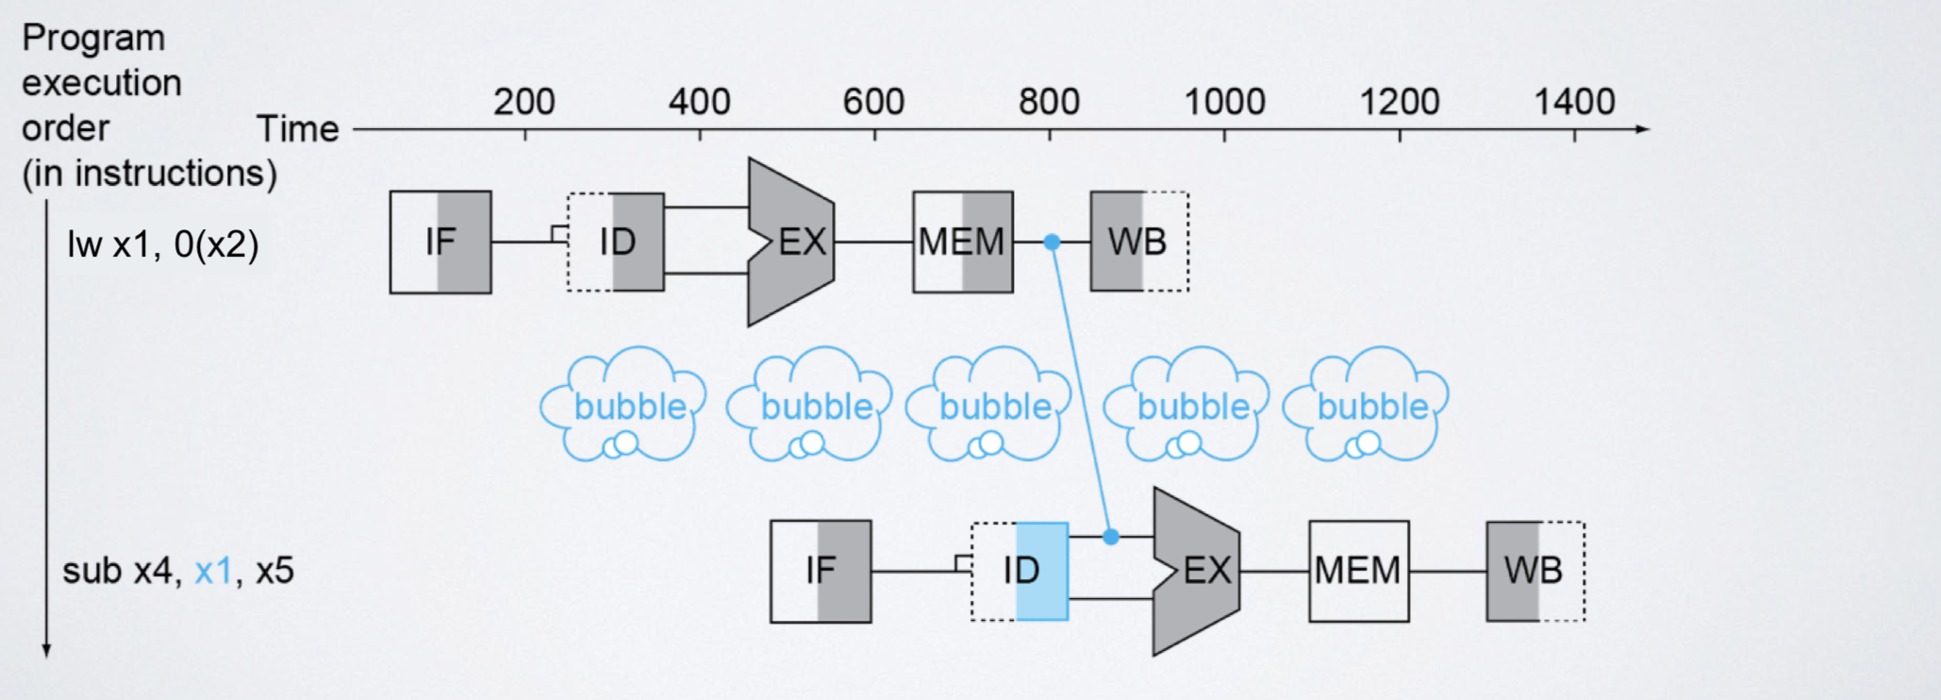

1. **Control hazard:**

Control hazards are hazards due to branch instructions. It cannot be handled using the forwarding technique. The branch could be determined in the MEM/EX stage. So, we need additional 3 cycles to know whether the branch would be taken or not. While waiting for the branch, other following instructions will start their cycles, which will cause incorrect/inaccurate data to be written in the register file. To solve this problem,we used Flushing

**Flushing:**

We flushed the following 3 instructions, in order not to have wrong outputs and to solve that problem

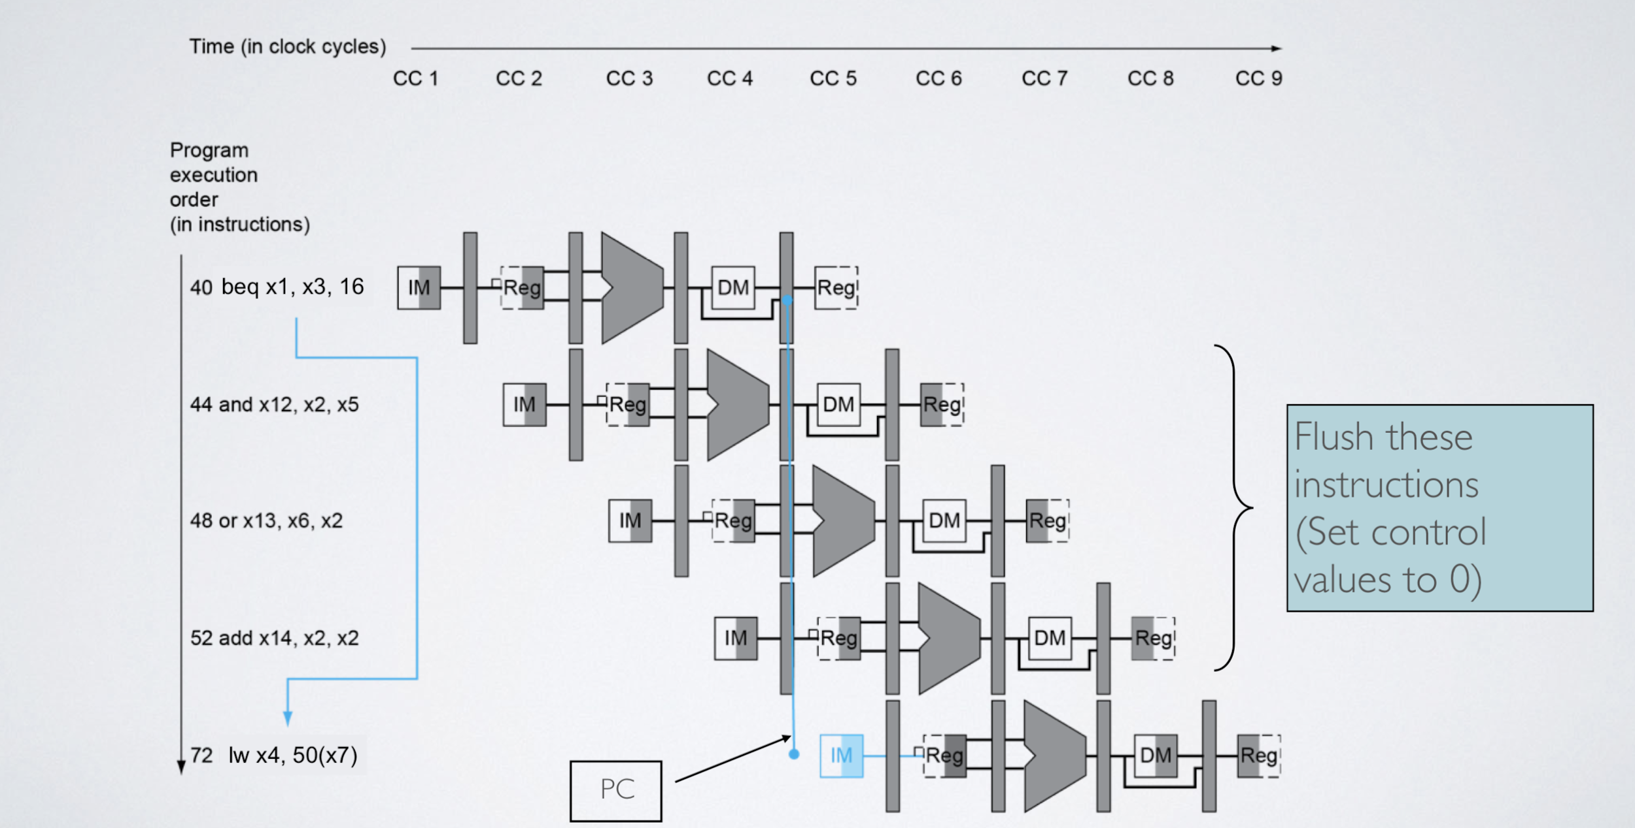

**Prediction:**

There is another technology we did not use which is branch prediction which helps in minimizing the delay. It depends on the a buffer which tells the branch to jump or not   
There are 5 types of branches

1. Always taken
2. Not always taken
3. Sign offset
4. 1 bit dynamic predictor
5. 2 bit dynamic predictor

**Design:**

We added some main components on the single cycle processor

1. 4 big registers
2. Forward unit
3. Hazard unit

**First we added the 4 registers**



**Secondly, we added the forward unit**

EX hazard

* if (EX/MEM.RegWrite and (EX/MEM.RegisterRd ≠ 0)  and (EX/MEM.RegisterRd = ID/EX.RegisterRs1)) 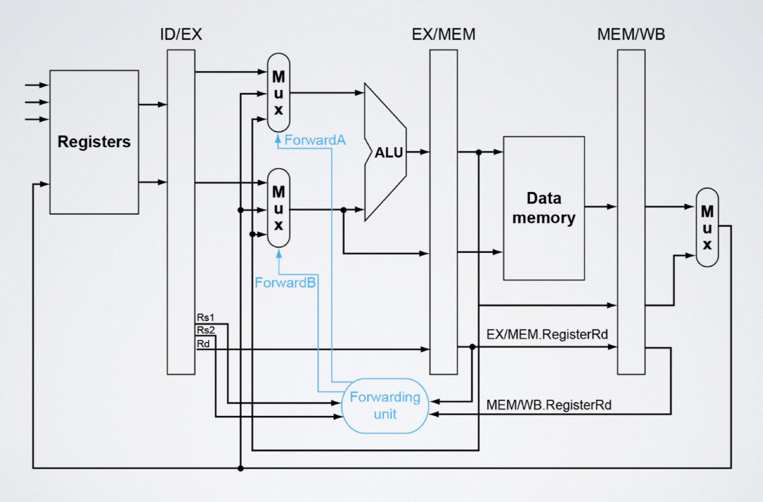

ForwardA = 10

* if (EX/MEM.RegWrite and (EX/MEM.RegisterRd ≠ 0)  and (EX/MEM.RegisterRd = ID/EX.RegisterRs2))

ForwardB = 10

MEM hazard

* if (MEM/WB.RegWrite and (MEM/WB.RegisterRd ≠ 0)  and (MEM/WB.RegisterRd = ID/EX.RegisterRs1))

ForwardA = 01

* if (MEM/WB.RegWrite and (MEM/WB.RegisterRd ≠ 0)  and (MEM/WB.RegisterRd = ID/EX.RegisterRs2))

ForwardB = 01

**Thirdly we added the hazard unit**

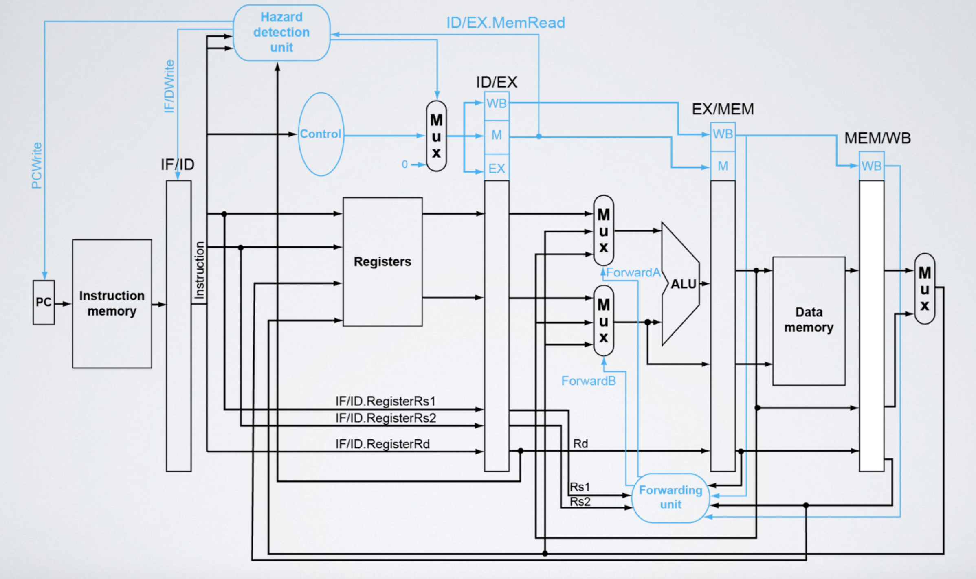

If the following condition happens then stall

ID/EX.MemRead and ((ID/EX.RegisterRd = IF/ID.RegisterRs1) or (ID/EX.RegisterRd = IF/ID.RegisterRs2))

So our design that support all the instructions of the risc-v processor :

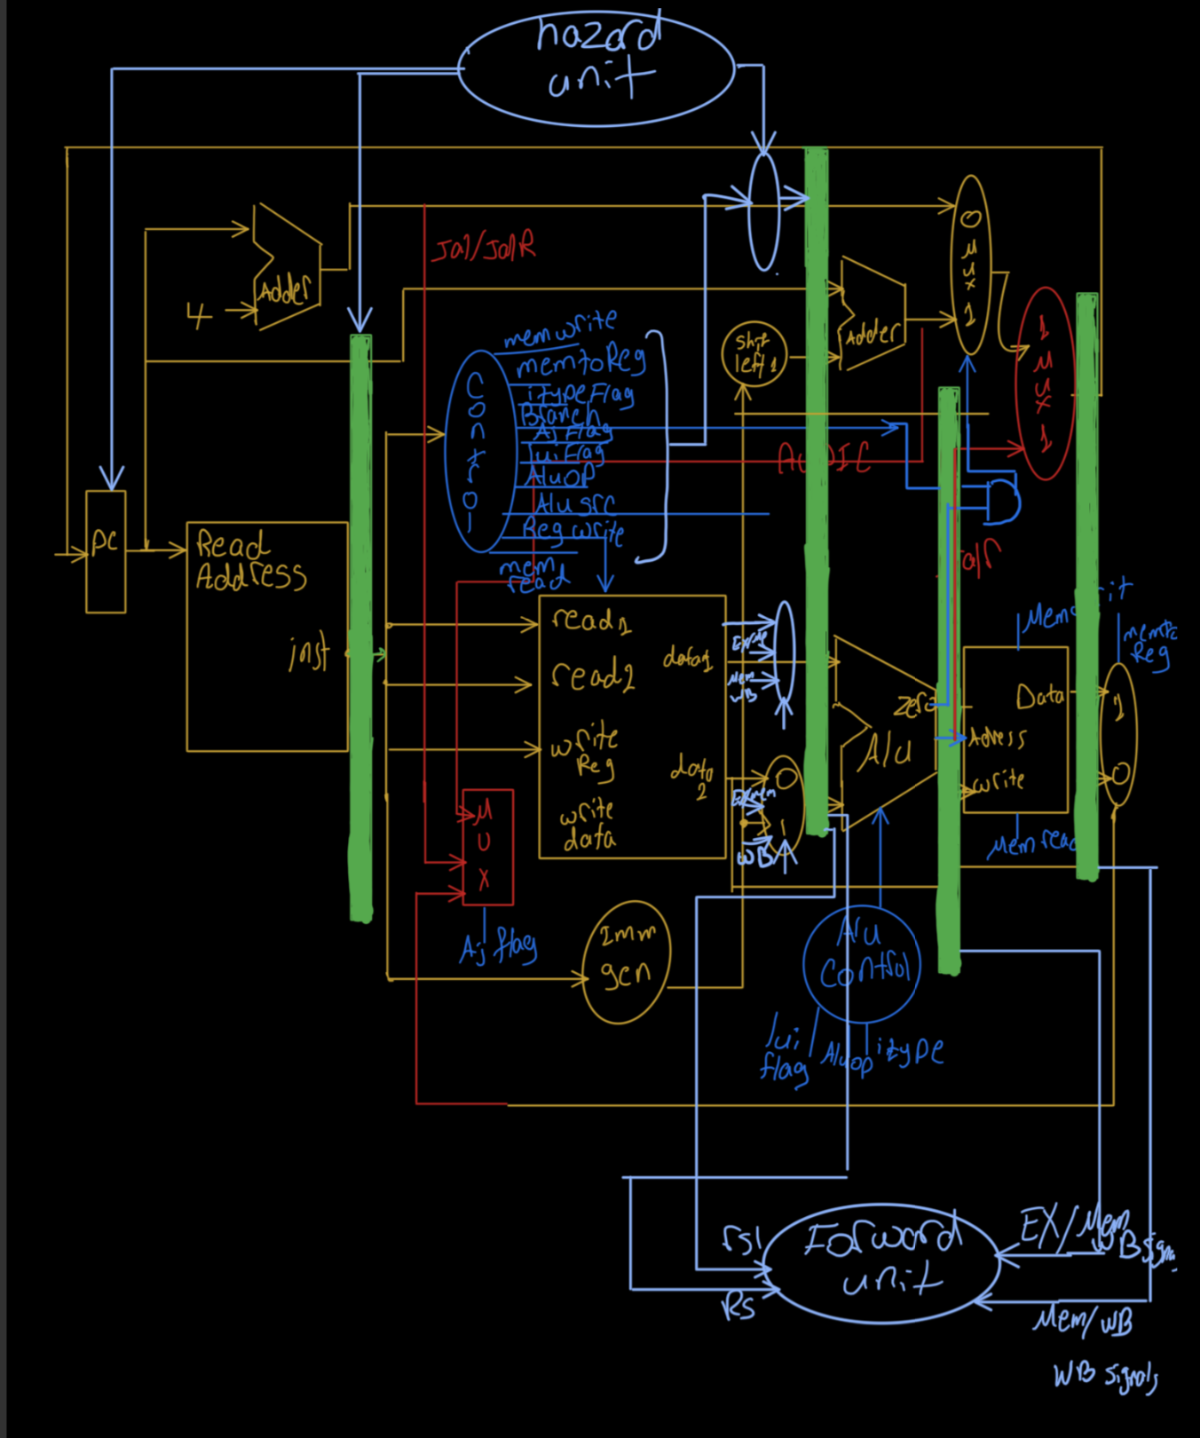

Note: Finally, we tried to make the instruction memory and the data memory in one single ported memory, this make us being delayed one cycle in order to take time from the memory the instruction, and another time take the data

**Testing:**

Test case (1) I-type :

|  |  |
| --- | --- |
| **lw t1, 4(zero) #12 ->1100**  **addi t3,t1,10 #22**  **andi t5,t1,10 #1000 ->8**  **xori t6,t1,10 #0110 ->6**  **ori s0,t1,10 #1110 ->14**  **slli s1,t1,2 #48**  **slti s2,t1,10 #0**  **sltiu s3,t1,10 #0**  **srai s4,t1,2 #3**  **srli s5,t1,10 #0** |  |

Simulation:

Register file data

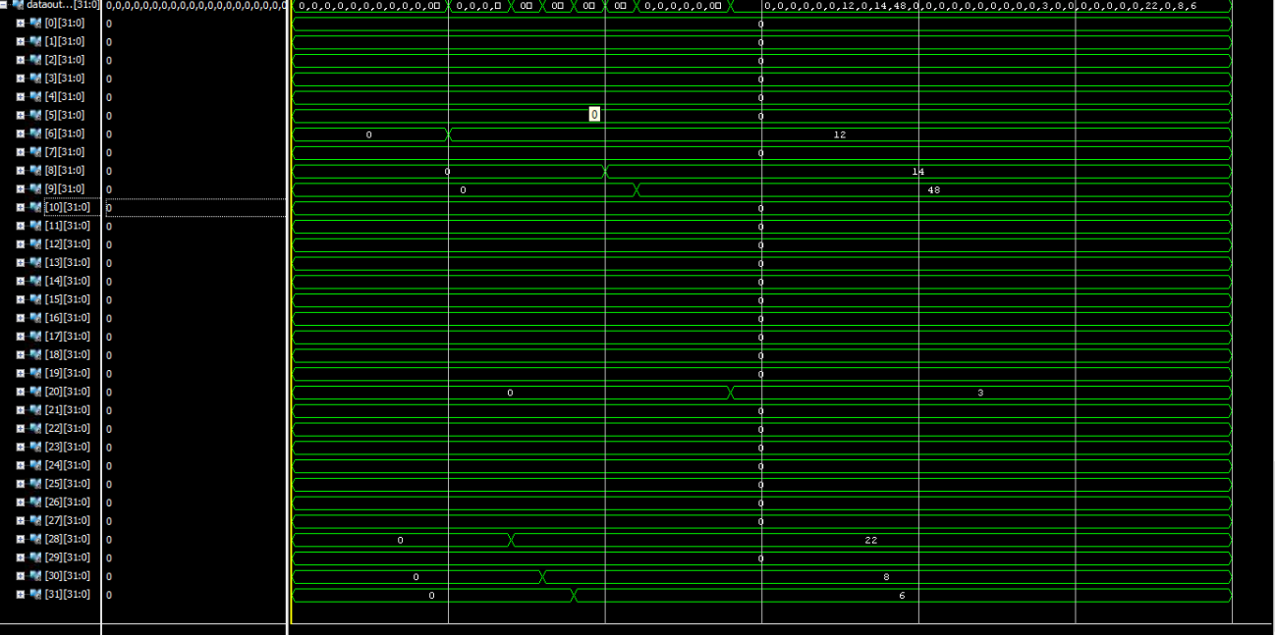

Test case (1) FPGA :

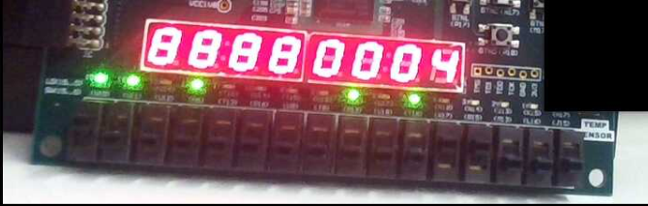

|  |  |  |  |  |
| --- | --- | --- | --- | --- |
| Instruction | ALU Result | LedSel | SSDsel | Output on leds |
| lw t1, 4(zero) #12 | 4 | 00 | 1010 | ? |

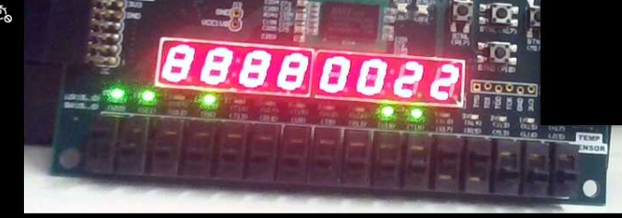

|  |  |  |  |  |
| --- | --- | --- | --- | --- |
| Instruction | Writing Data | LedSel | SSDsel | Output on leds |
| addi t3,t1,10 #22 | 22 | 00 | 0110??? | 11010000 |

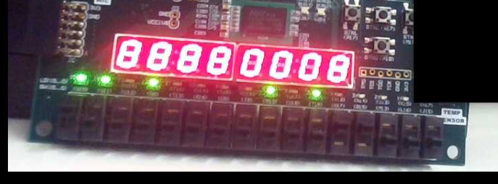

|  |  |  |  |  |
| --- | --- | --- | --- | --- |
| Instruction | Writing Data | LedSel | SSDsel | Output on leds |
| andi t5,t1,10 #8 | 8 | 00 | 1010 | 11010000 |

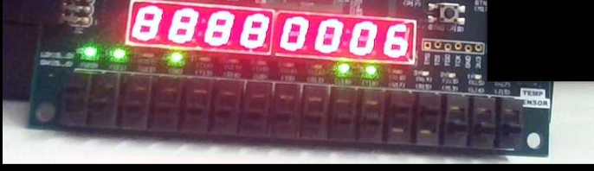

|  |  |  |  |  |
| --- | --- | --- | --- | --- |
| Instruction | Writing Data | LedSel | SSDsel | Output on leds |
| xori t6,t1,10 #6 | 6 | 00 | 0110 | 11010000 |

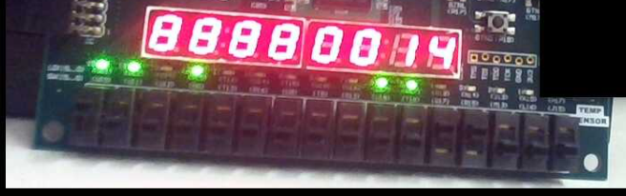

|  |  |  |  |  |
| --- | --- | --- | --- | --- |
| Instruction | Writing Data | LedSel | SSDsel | Output on leds |
| ori s0,t1,10 #14 | 14 | 00 | 0110 | 11010000 |

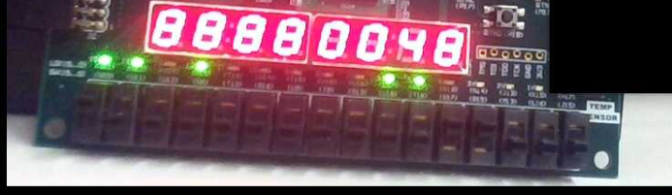

|  |  |  |  |  |
| --- | --- | --- | --- | --- |
| Instruction | Writing Data | LedSel | SSDsel | Output on leds |
| slli s1,t1,2 #48 | 48 | 00 | 0110 | 11010000 |

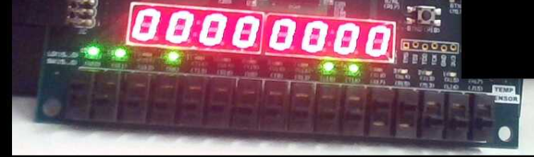

|  |  |  |  |  |
| --- | --- | --- | --- | --- |
| Instruction | Writing Data | LedSel | SSDsel | Output on leds |
| slti s2,t1,10 #0 | 0 | 00 | 0110 | 11010000 |

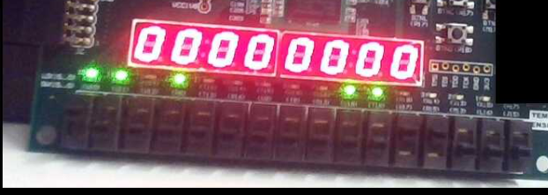

|  |  |  |  |  |
| --- | --- | --- | --- | --- |
| Instruction | Writing Data | LedSel | SSDsel | Output on leds |
| sltiu s3,t1,10 #0 | 0 | 00 | 0110 | 11010000 |

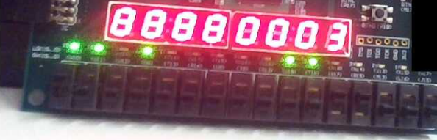

|  |  |  |  |  |
| --- | --- | --- | --- | --- |
| Instruction | Writing Data | LedSel | SSDsel | Output on leds |
| srai s4,t1,2 #3 | 3 | 00 | 0110 | 11010000 |

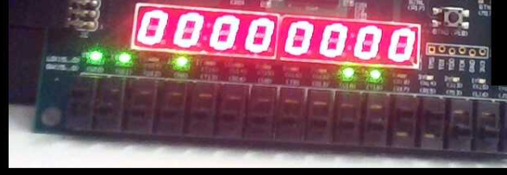

|  |  |  |  |  |
| --- | --- | --- | --- | --- |
| Instruction | Writing Data | LedSel | SSDsel | Output on leds |
| srli s5,t1,10 #0 | 0 | 00 | 0110 | 11010000 |

Test case (2) R-type

|  |  |
| --- | --- |
| lw t0, 0(zero) # 10 ->1010  lw t1, 4(zero) #12 ->1100  lw t2, 8(zero) #1 ->5  add t3,t1,t0 #22  sub t4,t1,t0 #2  and t5,t1,t0 #1000 ->8  xor t6,t1,t0 #0100 ->4  or s0,t1,t0 #1110 ->14  sll s1,t1,t2 #24  slt s2,t1,t0 #0  sltu s3,t1,t0 #0  sra s4,t1,t2 #6  srl s5,t1,t0 #6 |  |

Register file output

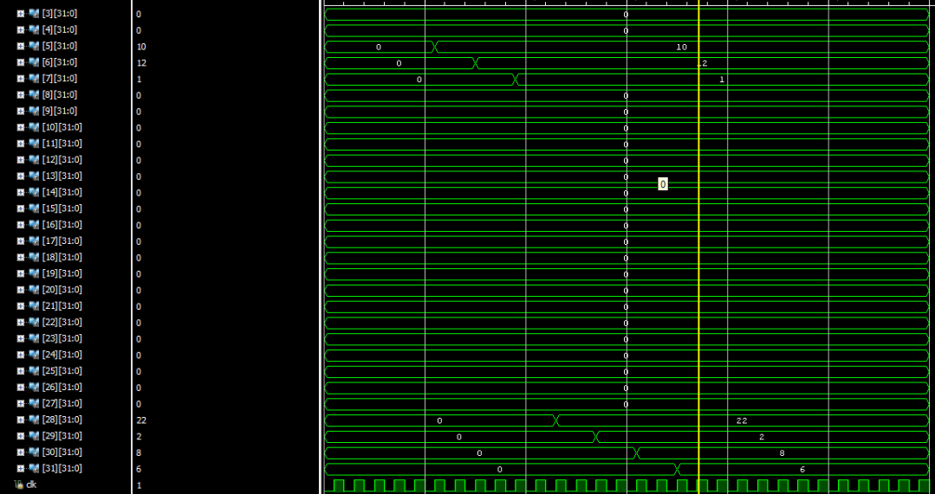

Test case (3) AUIPC &Jal &lui

|  |  |
| --- | --- |
| lw t1,0(zero)#0  lw t2,4,(zero) #12  lw t3,8(zero) #10  jal jumb  addi t1,t1,1  jumb:  auipc t2,10000  lui t3,10000  addi t4,zero,0 |  |

Register file output

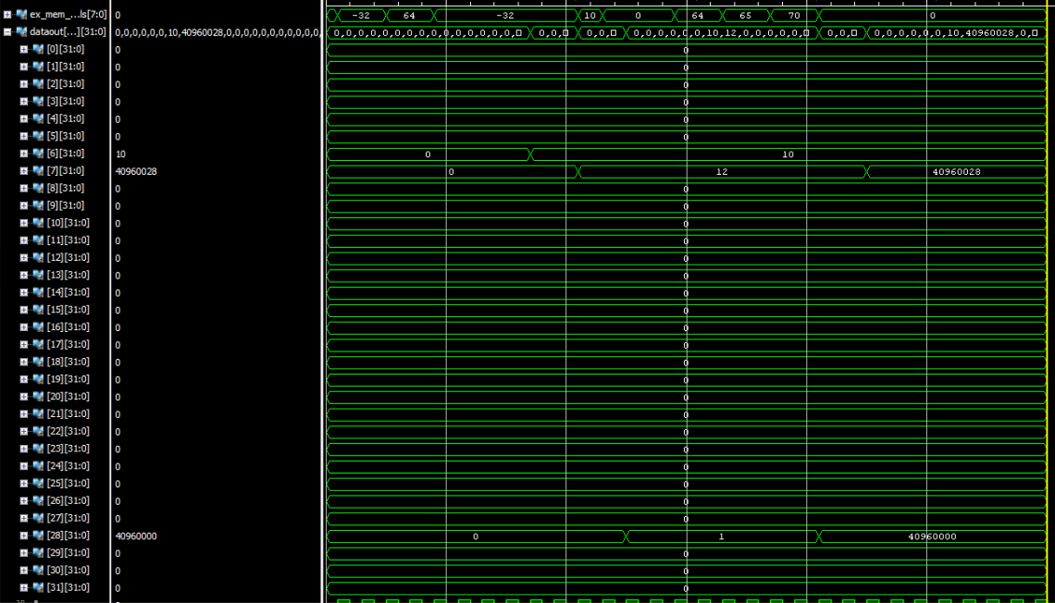

Test case for all instructions:

|  |  |
| --- | --- |
| lw x1, 0(x0) # 17  lw x2, 4(x0) # 9  lw x3, 8(x0) # 25  or x4, x1, x2 # 25  beq x4, x3, jumb # yes --> goto 24  add x3, x3, x2 # 34 should be skipped ,so x3 = 25  jumb:  sub x5, x3, x2 # 17 (pc =24)  sw x5, 12(x0) # -->  jal loop # goto 44 from 32  addi x4,x0,10 # 35 skipped  sub x3,x3,x0 # 25 skipped  loop: # pc= 44  lw x6, 12(x0) # 17  bne x6,x5,exit # continue  and x7, x6, x1 # 17  sub x8, x1, x2 # 8  auipc x10,100 # x10 = pc + 20upper = current pc = 60  lui x11,1000000 # 976  blt x10,x11,store # yes --> store  or x30,x3,x2 # 25 skipped  store :  sb x11,12(x0) # mem12 = 208  sh x11,16(x0) # 976  bge x3,x2,load # yes --> load  addi x4,x0,10 # 35 skipped  sub x3,x3,x0 # 28 skipped  load:  lb x20,16(x0)  lh x21,16(x0)  lbu x22,16(x0)  lhu x23,16(x0)  bgeu x20,x21,exit  bltu x20,x21,store  exit:  ebreak  fence 1,1  ecall |  |

Register File:

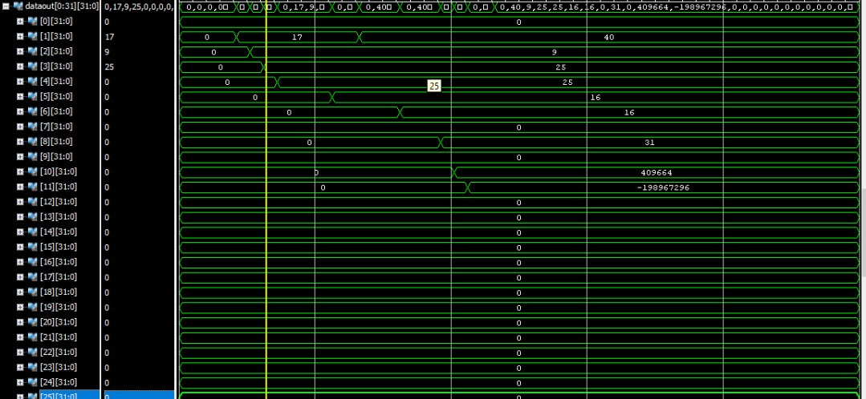

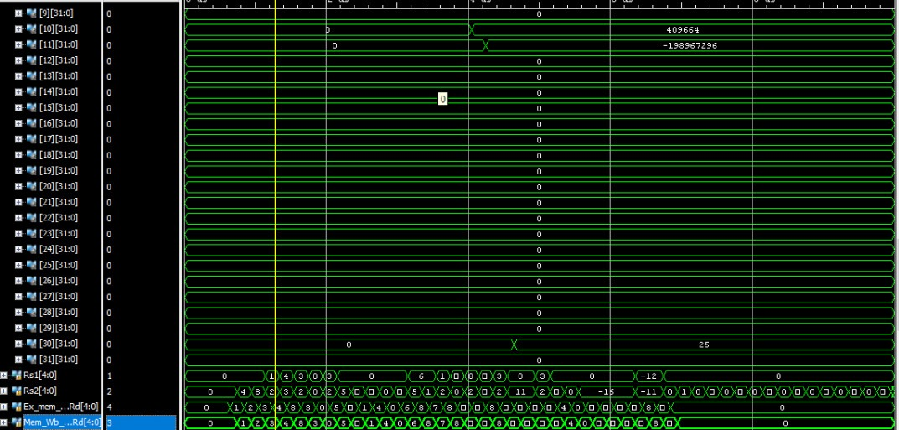

To test that ecall terminate the program:

The pc stops when finding ecall



Memory to see the store instruction works or not

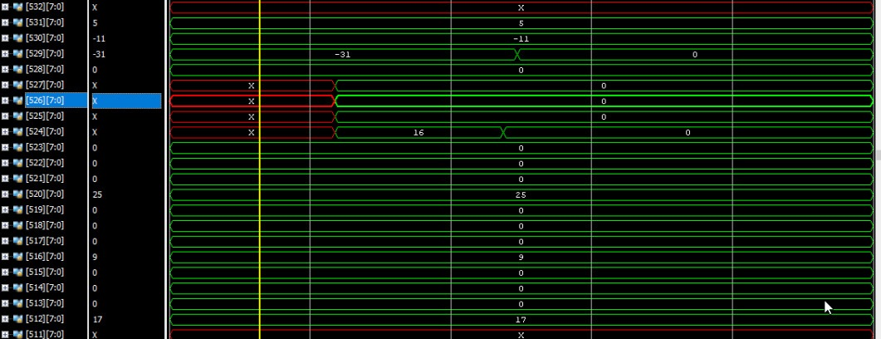

Test case For Jalr

|  |  |
| --- | --- |
| lw x1, 0(x0) # 17  lw x2, 4(x0) # 9  lw x3, 8(x0) # 25  jal ra, sum1  addi x4,x2,3  ecall  #the function  sum1:  jalr x0,x1,0  addi x5,x2,3 |  |

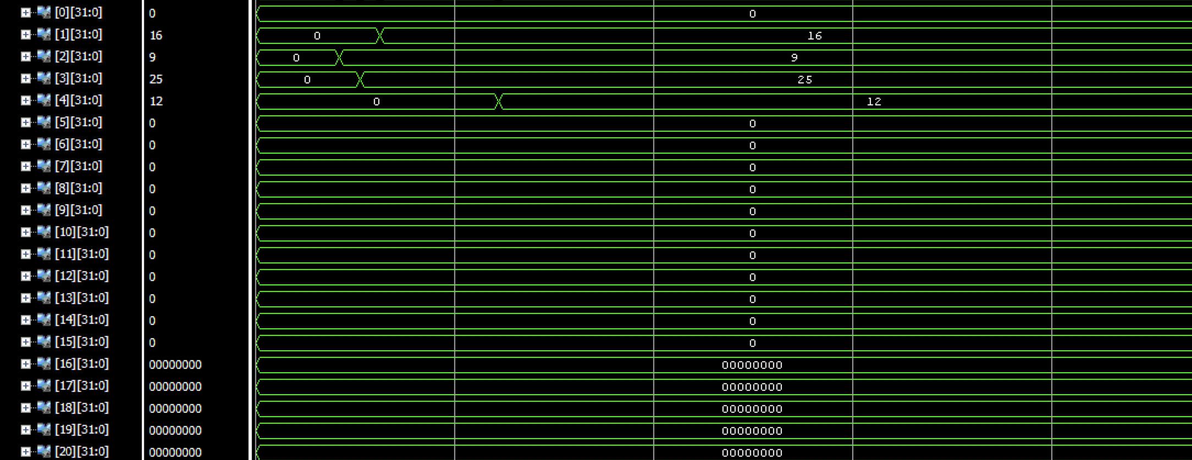

**Bonus features:**

Multiplication operations:

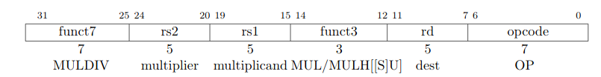

MUL performs a 5-bit × 5-bit multiplication of rs1 by rs2 and places the lower bits in the destination register.

MULH → perform the same multiplication but re-turn the upper 5 bits of the full 25-bit product for signed×signed.

MULHU→perform the same multiplication but re-turn the upper 5 bits of the full 25-bit product unsigned×unsigned.

MULHSU → perform the same multiplication but return the upper 5 bits of the full 25-bit product signed rs1 × unsigned rs2

If both the high and low bits of the same product are required, then the recommended code sequence is:

MULH rdh, rs1, rs2;

MUL rdl, rs1, rs2 (source register specifiers must be in same order and rdh cannot be the same as rs1 or rs2).

Microarchitectures can then fuse these into a single multiply operation instead of performing two separate multiplies.

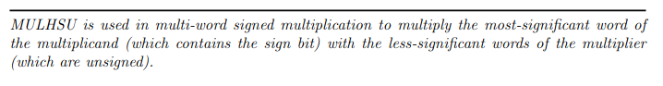

Division operation:

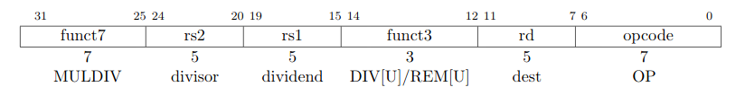

If both the quotient and remainder are required from the same division, the recommended code sequence is:

DIV[U] rdq, rs1, rs2;

REM[U] rdr, rs1, rs2 (rdq cannot be the same as rs1 or rs2).

Microarchitectures can then fuse these into a single divide operation instead of performing two separate divides.

We added this code in RARS to get the opcode of these instructions :

|  |
| --- |
| mul x0,x0,x0  mulh x0,x0,x0  mulhu x0,x0,x0  mulhsu x0,x0,x0  div x0,x0,x0  divu x0,x0,x0  rem x0,x0,x0  remu x0,x0,x0 |

This is the binary produced by RARS :

0000001 0000000000 000 00000 0110011

0000001 0000000000 001 00000 0110011

0000001 0000000000 011 00000 0110011

0000001 0000000000 010 00000 0110011

0000001 0000000000 100 00000 0110011

0000001 0000000000 101 00000 0110011

00000010000000000 110 00000 0110011

00000010000000000 111 00000 0110011

-----------------